THE EVOLVING WORLD OF COACHING

Keri Phillips

The world of coaching has changed dramatically in recent years, particularly this century; arguably it has been a revolution rather than an evolution. The purpose of this paper is to take stock for a moment and catch breath; namely to look a little more closely at those changes, their consequences and the challenges and opportunities which arise.
I will set the scene by considering briefly the wider context, then offer a model which seeks to provide an overview of the current nature of coaching; I then consider some of the repercussions. My aim ultimately, is not to offer a series of actions that might be taken. Rather if any of this paper resonates and prompts ideas, whether vague or clear, I hope then that this may lead to further explorations and discussions; hopefully productive and enjoyable.
In all this I am profoundly grateful for the valuable experiences I have had as a coach and supervisor with a wide range of people in professional settings, both formal and informal, and as always found richness and insights from chance conversations – ‘gifts from the universe’ - often with people who had no direct involvement in coaching and personal development; at least explicitly so, since one might argue that the vast majority of people are involved in helping others learn, whether intentionally or not.

Setting the Scene
As readers of my previous paper, ‘Coaching and the Pandemic’ (Phillips, 2021) will know, I discovered that a ‘chance visit’ can be valuable for prompting an underlying strand of thought. This time it was the Whitewall Galleries in King Street, Manchester. The two paintings below immediately resonated with me.
SHADES OF DAWN by Anna Gammans
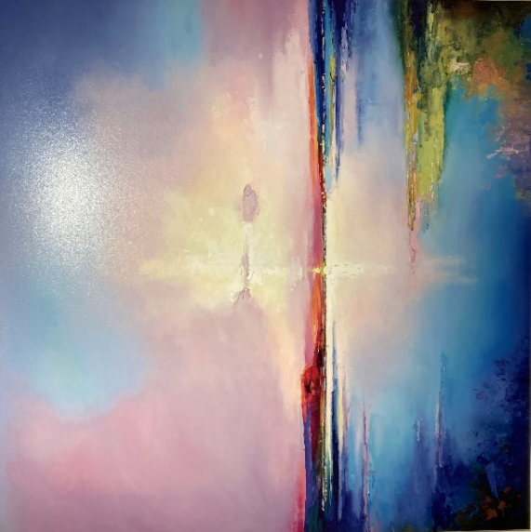

VOLCANIC SCENES by Philip Gray
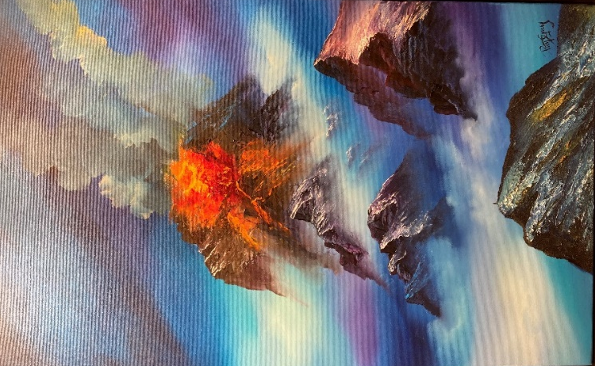
For me, they were in sharp contrast to each other: stillness………and eruption, thus capturing two very different aspects of the world. My sense is that we often see and experience such contrasts, sometimes close to home and sometimes in faraway places. Also, home can seem faraway and vice versa. The move from one to the other and back again, sometimes like a pendulum, can be very speedy. At other times it can happen slowly, almost outside awareness and then there is the sudden realisation of the movement. Also, particularly in these days of the internet, ‘faraway’ can be experienced as profoundly intimate.
The third painting which caught my attention and imagination a few minutes later was this one:
LUNA by Rich Parker
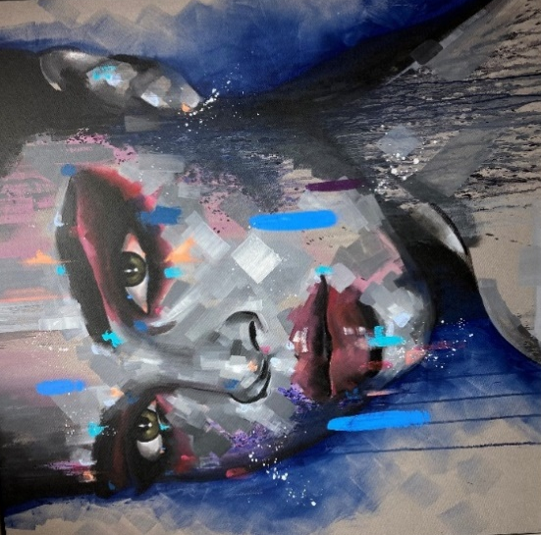
It seemed to convey an important element in coaching, that is supporting the client in seeing as clearly as possible, and also to be willing to look away. I add this latter point because after a short while looking at the picture I felt quite sad; I am truly unsure why. So I distracted myself by looking at this:
RITRATTO URBANO DI NOITE by Paolo Fedeli
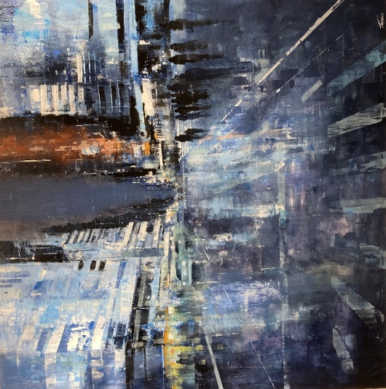
It reminded me of New York City and my last trip there a few years ago for the happy time attending my son’s wedding.
The earlier contrasting paintings also reminded me of a theme, often core in coaching, namely the coach being a part of and apart from the client’s world; that is, moving along a spectrum of appropriate closeness and distance in order to support the client in their aims. The client might be navigating their way through some tricky and contrasting landscapes. I elaborate on this later.
Having reached this point in my meander, perhaps pilgrimage, (Solnit, 2002) through the gallery I decided to capture some of my strands of thought, whether vivid or grainy. My reflections ultimately led to this paper and an opportunity to see with a fresh pair of eyes:
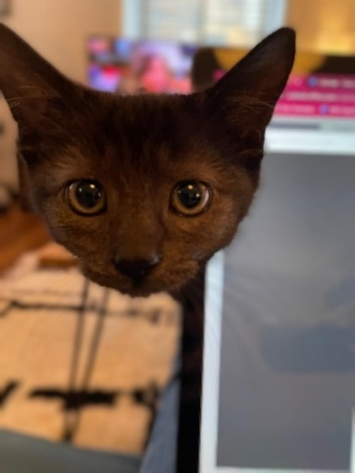

The Overview Model
I now offer the model I previously mentioned followed by an explanation. It will also be a reference point through much of paper.
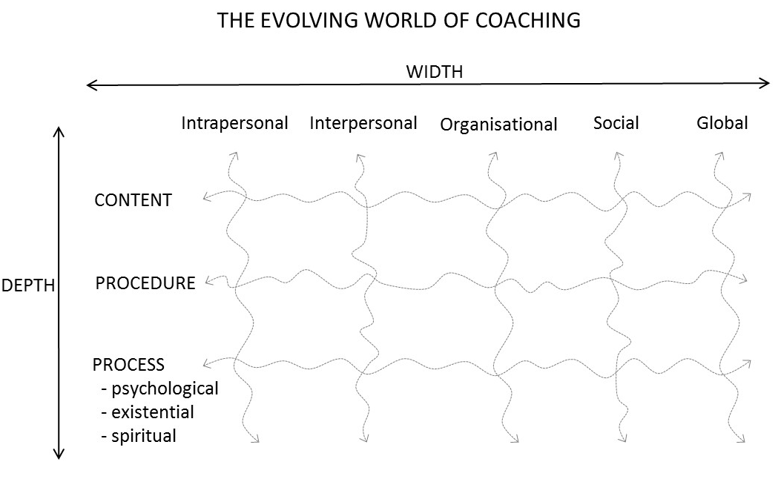
Some words of explanation about the diagram.
Regarding the Depth dimension:
- Content refers to the apparent stated topic of the coaching conversation, whether clear, vague or a mixture. I use the word ‘apparent’ because it may well change over time.
- Procedure refers to the coaching methods and approaches used; for example, the GROW model – Goal, Reality, Options, Will (Whitmore, 1992); storytelling, psychometrics, physical movement such as chairwork, imagery/art, walks through nature and many other possibilities; also it may be at-a-distance or face-to-face. The length and frequency of the sessions also varies hugely. It may range from a relationship lasting many years through to a one-off session lasting perhaps an hour or even less with a ‘stranger’; for example at a coaching conference or in a drop-in centre (Dryden, 2022).
- Process refers to the underlying feelings and motivations, some of which may be deliberately hidden or simply outside awareness. They may relate to the ‘here and now’ relationship with the coach, perhaps also influenced by other emotions from the recent and/or distant past; or simply, for example the reluctance or eagerness of the client to attend the coaching session. Along this psychological strand there may well be interwoven elements. Hence process also includes the existential aspect which relates to the wider and deeper aspects of the client’s life, for example identity and sense of self worth. There might also be a legacy of intergenerational trauma (Fromm, 2022; Epstein, 2022). The spiritual aspect may include the client’s overarching purpose in life, its meaning and their soul in a religious or non-religious way or both.
As intimated earlier, there can be a rapid ebb and flow between these aspects, even within one session. I am also reminded that trauma can collapse the distinction between the external world and internal experience. So my use of a Depth line may be slightly misleading because its linearity implies sequencing. Rather there may be sudden moves from one aspect to another, such as from Content to the Spiritual, including U-turns and apparent dead ends.
My point about linearity also applies to the Width dimension.
- Intrapersonal refers to one’s relationship with oneself; for example, the voices in one’s head and heart being loving or contemptuous and the many points in-between; they may be real or imagined voices from the past, present, future or a mixture. The person may be unclear about the source. I am also reminded of a client speaking of ‘stepping back into her own body’; that somehow, not necessarily due to our work together, she had a new, yet old relationship with herself.
- Interpersonal refers to one’s interaction with others in an almost infinite range of settings and circumstances. I recall talking to Jacob who told me that as a seventeen year old he and his mother worked together to redecorate his bedroom. For him it transformed their relationship because for the first she treated him as an adult.
- Organisational refers to many different contexts within the wider culture; for example, the norms and values of one’s employment and the community groups to which one belongs through choice, obligation, circumstances or a mixture. I am also reminded that in the United Kingdom there are frontline staff, such as nurses, domestic workers and carers, who are crucially needed but often marginalised being less well paid and supported (Scanlon & Adlam, 2022).
- Social refers to the yet wider setting again in terms of the broader culture in which one lives. This may include, for example, having a sense of home in many different places. Through choice or not one may have developed versatility in using one’s alertness and flexibility to move between many different cultures. There will also be those who have no sense of home and belonging. Also there is sometimes the challenge of needing to have a home in order to develop a sense of self, whilst also needing a sense of self in order to have a home.
- Global refers to the still wider context. For example, there is polarisation and conflict regarding the war in Ukraine also significant divisions in U.S. domestic politics. They are currently themes affecting much of the world, sometimes overlapping. Also, locally and globally the rich are getting richer and the poor are getting poorer. There may the relentless erosion of democracy (Gandesha, 2022). For example, in the United Kingdom the House of Lords is increasingly being filled with political cronies and party donors. Its credibility is fading. Also as indicated earlier, technology can dramatically facilitate a sense of connectedness and disconnectedness, sometimes with dramatic switches between the two – from adored insider to detested outsider.
The dotted lines indicate the interconnectedness of it all and the multiplying possibilities. In the early days of management coaching the emphasis was often largely on job performance. Over the years the context for such work has changed dramatically, including a far greater acceptance of the Process dimension. Recently the pandemic has brought this as a vivid presence in the coaching room in terms of death, mortality and loss more generally (Barnett, 2009). In losing a loved one, one loses part of oneself. Another example would be the almost breath-taking speed with which ‘the systemic’ has made its presence felt within a wide variety of settings, including the work of the Tavistock Institute (Sher & Lawler, 2022; Barbetta et al 2022; Dallos & Vetere, 2022; Lawrence, 2021). This also includes intersectionality; the ways in which a blend of factors such as race, gender, sexual orientation and physical ability may fuel discrimination and privilege (Logan, van Eeden- Moorefield & Browning, eds. 2022).
The emergence of team coaching and family business coaching have also been activities in this move to a wider perspective (Shams & Lane eds, 2011). The broader setting in its many manifestations is regarded as crucial for understanding what is or might be happening in the coaching session whether it is taking place in a room, or on a zoom call, or is a corridor coffee chat or a windy walk in the local park. Clearly something like the challenge of global warming has huge implications within and across all dimensions of the Overview Model (Holloway et al, 2022). One aspect is no longer being able to cling to the self-delusion that humankind is omnipotent in relation to the environment (Clarkson, 2022).
I now move on to consider some of the possible opportunities and challenges that may be the consequence of the above. In doing so I am aware that I may sometimes create for myself a Catch-22, such as, ‘There are absolutely no permanent truths!’.
The Possible Consequences
Being A Part of and Apart From
With the model in mind, I suggest that balancing being ‘a part of’ and ‘apart from’ has become even more necessary and challenging. That is, moving helpfully and appropriately, back and forth along the spectrum of closeness and distance. It provides a transitional space. The transitional space may well have a strand, even theme of vulnerability in holding uncertainty, ambivalence and ambiguity. A sense of being held is important for all parties and being sufficiently safe. This is further illustrated in the model below (Phillips, 2010). It assumes that a coaching session has taken place and that the coach then, at some point – immediately or later - receives supervision. All of the positions involve the person, whether client, coach or supervisor being both a witness and a participant; that is, engaging and being an observer of self. Being a part of and apart from is both an internal (intrapersonal) and external (interpersonal) activity with strands of content, procedure and process.
This activity is in many ways dependent upon both parties feeling sufficiently ‘held’. So, for example, the client feels sufficiently supported by the coach - neither suffocated nor abandoned. Clearly, within the Wide and Deep range of possibilities outlined earlier there may be challenges associated with this. One instance would be where both parties may have had to cope with the death of a loved one in the pandemic. Perhaps for the supervisor it meant learning to live with the fact that during the period of mourning a member of the family had felt liberated by the death and felt free to say so, and in no uncertain terms. Meanwhile the supervisee brings to the session his anger and frustration about a lack of clarity in her role, which for the supervisor has echoes of his childhood, being constantly being moved around schools because of his mother’s global work. With so much to hold it may mean, for example, that the supervisor whilst intending to make a Bull’s Eye transaction intervention ends up making what I call a Bullying Eye transaction. A Bull’s Eye transaction, from the world of transactional analysis, is intended to resonate positively, that is helpfully with the client in terms of Values - Parent, Making Sense - Adult and Feels Right – Child (Woollams & Brown, 1978). The Bullying Eye resonates negatively in all those ego states.
Arguably, with the intense range and depth of issues that may occur in coaching and supervision and the associated emotional and practical demands then each party needs a sense not only of being supported but also of being loved in their lives. I use the word ‘love’ a touch provocatively. I am aware that love has many facets and can be seen, perhaps experienced as a ‘second hand emotion’ – Tina Turner. My point is simply that in this current world of coaching, with a growing width, depth, ebb and flow then a trusted intimacy with self and others may be increasingly important; some relatively solid ground, albeit possibly temporary. Support alone may be insufficient. I am also aware that greater intimacy can trigger greater fear (McWilliams, 2021). On occasion an intra and interpersonal pendulum swing may arise.
In this regard I am also reminded of W.G. Lawrence and the pioneering work of others in the 1970’s at the Tavistock Institute exploring individual and organisational boundaries (Lawrence, 1979). If a member of the consultancy team feels closer to the client than she does to her team consultancy colleague then there is the greater likelihood of poor contracting. The point is made that the depth of relationship between the members of the consultancy team needs to be at least as deep as the relationship that the consultancy team member is seeking to establish with the client. These days, coaches may be organisation development consultants and are already be familiar with this legacy. However, switching roles may also lead to changes in terms of self-perception and identity, sometimes prompting the de-skilling of self.
Learning Loops
The Positions Model also indicates the possibility of learning loops at those positions. This draws on the work of Chris Argyris who referred to the importance of stepping back to revisit assumptions and the assumptions about assumptions (Argyris, 1977). For example, ‘How do we get this room temperature up to 65 degrees for the meeting today?; does it need to be at 65 degrees?; does the meeting need to be in this room?; is the meeting really needed today?; is the meeting needed at all?’ etc. Each of the positions might indicate a questioning of the assumption that underlay the previous position. The devil’s advocate may also sometimes have a valuable role.
The wider range of cultures and perspectives emerging from the globalisation of coaching may support such learning loops, for example, bringing the wisdom of the newcomer who was recently an outsider, ‘Why do it this way?’. Also different cultures will have a wide variety of rules regarding etiquette, dress, ethics, language, non-verbal communication, eye-contact and so on. For example, I was interested to read recently that in Iran the use of the word ‘I’ is much more limited (Zarbafi & Wilson, 2021). I remember many years ago at a gestalt-based training workshop being urged to own my words and feelings more by greater use of the word ‘I’. For some it may be that on occasion not using one’s mother tongue enables a stepping back from oneself, for example into the 3rd position. So lots of learning possibilities. However sometimes these may be smothered by an assumed orthodoxy, wielded by those who are in power. In this regard I am reminded of the world of psychoanalysis where there was, perhaps still is, some extensive conflict between those who supported drive-based concepts and those who supported relational-based concepts (Bollas, 2022; Mitchell & Black, 1995). It was not simply a matter of different approaches, but absolutely right and absolutely wrong! I am also reminded of a recent brilliant book by Michaela Chamberlain describing how misogyny became institutionalised in the profession of psychoanalysis and how it was not able to apply its own treatments to itself (Chamberlain, 2022).
Multiplicity of Boundaries
In order to pursue this dimension I offer a model of the coaching community.
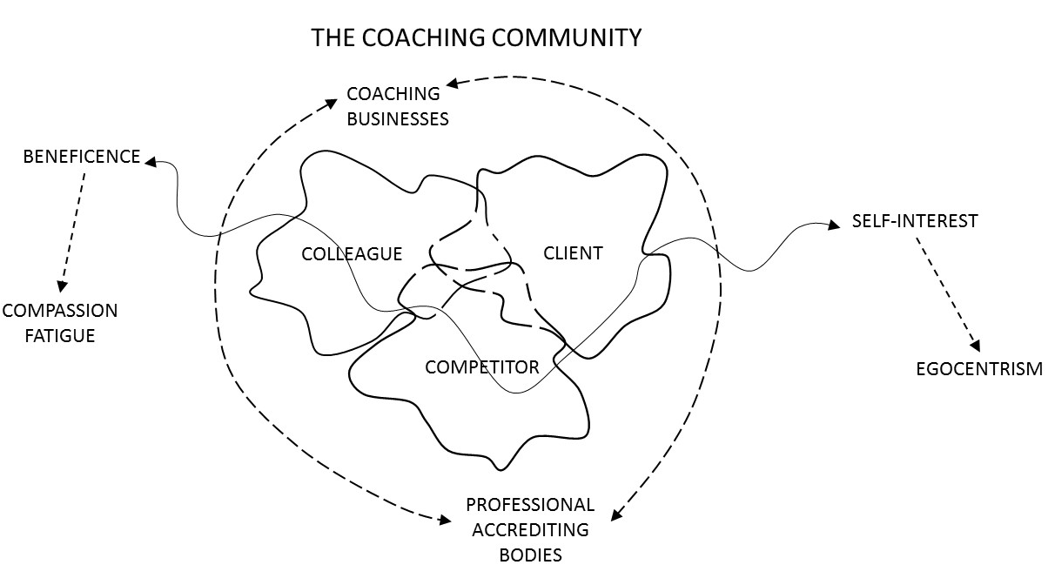
The boundaries, individual and collective are overlapping and may well be shifting, including movement between the highly labile and the highly rigid. This can create a number of challenges, often overlapping.
There are different and evolving roles and identities – teacher, student, applicant, consultant, supervisor, friend, mentor, client – short term, long term, formal and informal. In times of evolution and revolution, local and global questions such as the following may arise:
‘How do I navigate myself and my clients through the growing and evolving range of qualifications?’. ‘I thought we were friends, now we seem to be competitors. Or am I being paranoid?’; ‘Who really has the power at this moment in time?’; ‘Is it safe to tell the truth?’; ‘If I do so will I damage my reputation, indeed my global reputation and perhaps be ostracised, albeit with respect?’ ‘I thought I was an applicant, but I feel like a supplicant. Somebody needs to grow up. Is it me or them?’. ‘Who am I supposed to be now?’; ‘What do I really want?’. ‘Do I really want this role on the committee?. I know it would be good for my CV, but I don’t want to get bogged down in it. Maybe I can just turn up and do the minimum?’.
Such questions may come from self or self as a representative, they may be individual or collective, they may be fleeting or enduring. Being a representative can be empowering and burdensome, sometimes shifting almost imperceptibly between the two. Also the stakeholders cover a wide range, for example, from sole traders to private equity companies.
Any of the above is likely to affect the degree of engagement, as indicated in the model. This extends between Beneficence and Self-Interest with many spectres along the spectrum. For instance there may be a drift or leap from Self-Interest to Egocentrism or from Beneficence to Compassion Fatigue (Morrissette, 2022). Where there are such intensities they may be sparked by the person regarding the coaching community as home. Again there may be reverberations of the recent or distant past – such as one’s own family or lack of it. Below I consider the home perspective more fully.
In the light of the above one may not be clear where one belongs; where one can feel at home and feel unconditionally held. This can lead to a number of possibilities:
- Work becoming a religion, as described by Carolyn Chen regarding Silicon Valley (Chen, 2022), fuelled by an urgency to create a new identity. The accompanying passion may also energise capitalist surveillance (Zuboff, 2019); perhaps also an acute alertness to heresy, however defined, whether local or global. This alertness may be directed inwards as well as outwards. Over the centuries many religious groups have been fiercely focussed on themselves in terms of questioning whether he or she is still a ‘true believer’. ‘Does she or he truly accept THE truth and can we still have them as a member of our family?’. This also has parallels with a facet of the current state of world politics – ‘is she still truly one of us?’ I am also reminded that rituals can be a conduit or block to intimacy. They may also shift over time. One voices the script but no longer from the one’s heart and soul; perhaps there are also similarities to the politician being coached on what to say to the anticipated difficult question.
- Deification of the guru or celebrity; a profound need for certainty in turbulent times and an opportunity for apparent intimacy with other believers. It may be that the guru does not seek to present herself or himself as such an embodiment. Rather, it is about the followers seeking to cope with existential anxiety. It may sometimes mean that the guru’s speculations are treated as the absolute truth.
- Polarisation; if one feels unloved at the level of being then that can fuel being dismissive of others. A disagreement about professional theory and practice can lead to ‘otherisation’ where they become bad people. This happened in various phases of the evolution of psychoanalysis. There might also be Schadenfreude, taking pleasure from the misfortune of others can also be a cause and consequence of polarisation (Watt Smith, 2018). Sometimes a dislike of others can be fuelled by a dislike of self.
Through all this there may be an accentuated ambivalence because of wanting yet not wanting to belong because truly saying hello might mean truly saying goodbye to much that one treasured in the past (Ringel, ed. 2022).
In summary the coaching community, I suggest, is faced with many challenges regarding balancing competition and collaboration. If there is a loss of balance then this may lead to self-idealisation. ‘I have created this wonderful app that will magically transform your life forever; I guarantee it!’. There may also be a downplaying of the work of competitors, for example through subtle hints on social media, or even misinformation. There may be echoes of sibling rivalry and scapegoating, whether individual or collective. I was tempted to suggest that some of these dynamics might also originate with, ‘I bet mine is bigger than yours’, but I did not want to be seen as an advocate of drive-based concepts.
Beyond the coaching community there is the customer community. Clearly any unfinished business from the former may be exported to and played out in the latter. For example, there may be ‘collective projection’, attributing disliked or unacknowledged aspects of self onto the other. ‘That lot over there just don’t take any responsibility for their mess ups!’. Of course it might well be that such words are not actually used but are disguised by contrived compassion and the use of ‘professional internal jargon such as, ‘They are struggling with collective projection, we need to reach out to them with an open hand’. From a devil’s advocate position I suggest that sometimes customers might be left feeling that it is Same Hell Different Devils:
SAME HELL DIFFERENT DEVILS by Todd White (Whitewall Galleries)

The customer’s sense of history repeating itself may be particularly vivid because of recalling being betrayed by the person who was supposed to be their guardian angel; it may go back to childhood or even previous generations.
I now move on to the conclusion and a brief story.
Conclusion
Recently I had a ‘chance conversation’ with a barista called Jacob who works in a café, Ancoats Coffee near Piccadilly Station, Manchester. He mentioned to me that he had a book inside him but was not being rigorous enough in ‘getting on with it’. I decided to be a bit pushy with him and suggested that he get started that week and update me when we next met in a few days time. Having left the café I suddenly decided that I wanted to give him something tangible from our chat that might be a gentle nudge. I went straight to the Northern Quarter and bought a card from UNITOM. A copy of the picture on the card is below. Interestingly there were also copies of Liz Halls’s book, ‘Coach Your Team’ on the shelves. This is a unique bookshop which embodies and displays many different cultures in many different formats. Seeing Liz Hall’s book confirmed for me that getting the card was a good idea.
I went straight back to the café to give Jacob the card. When I next checked in with him he had made progress and was pleased with my help. I had been a bit concerned that I had been too pushy.
By Cari Vander Yacht
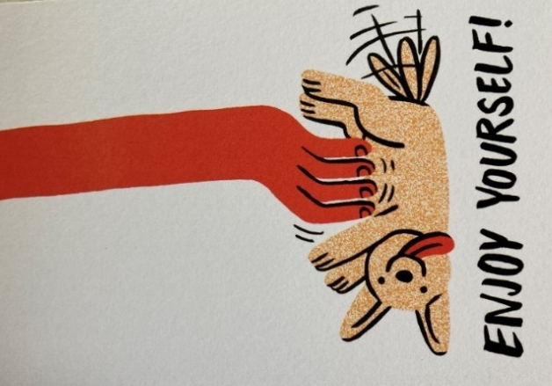

The advice I gave him was advice I also ended up giving myself; namely to enjoy the writing. I felt liberated and it really helped me put this paper together. Thank you Jacob!
Postscript
I went to Costa Café in Wilmslow in order to continue my editing of this paper. As I was coming towards the end of my time for doing this I happened to look across at the couple who had been sitting at an adjacent table. The woman had been supporting her friend as he concentrated intensely on his lap top, exchanging ideas and comments. In putting my papers together I then noticed that she was gently stroking the back of his neck as he continued to concentrate on the screen. I saw this as confirmation of my point about the importance of love in the world of coaching. After a few words of discussion they were happy for me to write about that moment.

Post Postscript
THE JOURNEY BEGINS by Fung Ming Yan
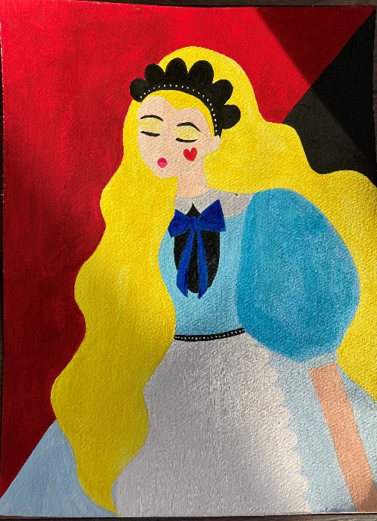
(Painted after reading the paper)

References
Argyris, C. (Sept-Oct 1977). Double-Loop Learning in Organizations. Harvard Business Review.
Barbetta, P.Cavagnis, M. Krause I-B, Telfener, U. (2022). Ethical and Aesthetic Exploration of Systemic Practice, Abingdon, Routledge.
Barnett, L. ed (2009). When Death Enters the Therapeutic Space. Hove. Routledge.
Bollas, C. What is Theory? Salberg, J. ed. (2022). Personal and Professional Journeys of Psychoanalysts. Abingdon. Routledge.
Chamberlain, M. (2022). Misogyny in Psychoanalysis. Bicester. Phoenix.
Chen, C. (2022). Work, Pray, Code: When Work Becomes Religion in Silicon Valley. Princeton University Press.
Clarkson, L. Trees and Other Psychoanalytic Matters. Moss D. & Zeavin L. eds. (2022). Hating and Abhorring – Wishing to Destroy. Abingdon. Rourledge.
Dallos, R and Vetere, A. (2022). Systemic Therapy and Attachment Narratives. Abingdon Routledge.
Dryden, W. (2022). Single Session Therapy. Abingdon. Routledge.
Epstein, O.B. ed. (2021). Shame Matters. Abingdon. Routledge.
Fromm, G.F. (2022). Travelling Through Time. Bicester. Phoenix.
Gandesha, S. A composite of King Kong and a suburban barber: revisiting Adorno’s, ‘Freudian theory and the pattern of fascist propaganda’. Moss, D. & Zeavin, L. eds. (2022) Hating and Abhorring – Wishing to Destroy. Abingdon Routledge.
Gilbert, P. and Simos, G. eds. (2022). Compassion Focussed Therapy. Abingdon. Routledge.
Holloway, W, Hoggett, P, Robertson, C, and Weintrobe, S. (2022). Climate Psychology. Bicester. Phoenix.
Lawrence, W.G. ed. (1979). Exploring Individual and Organisational Boundaries. Wiley.
Lawrence, P. (2021). Coaching Systemically. Abingdon. Routledge.
Logan J. & van Eeden-Moorfield, B & Browning. S. (2022). Constructing Authentic Relationships in Clinical Practice. Abingdon Routledge
McWilliams, N. (2021). Psychoanalytic Supervision. Guilford Press.
Mitchell, S. & Black, M. (1995). A History of Modern Psychoanalytic Thought. New York. Basic Books.
Morrissette, P. (2022). Self- Supervision: a Primer for Counsellors and Human Services Professionals. Abingdon. Routledge.
Phillips, K. (2021). Coaching and the Pandemic. Manchester. KPA.
Phillips, K. (2010). Coaching and Betrayal. Manchester. KPA.
Ringel, S. ed. (2022). Loss, Grief and Transformation. Abingdon. Routledge.
Shams, M & Lane, D eds. (2011). Coaching in the Family Owned Business. London. Karnac.
Sher, M. and Lawlor, D. (2022). An Introduction to Systems Psychodynamics. Abingdon. Routledge.
Scanlon, C. & Adlam, J. (2022). Psycho-social Explorations of Trauma, Exclusion and Violence. Abingdon. Routledge.
Solnit, R. (2002). Wanderlust. London. Granta.
Watt Smith, T. (2018). Schadenfreude. The Joy of Another’s Misfortune. London. Wellcome Foundation.
Whitmore, J. (1992). Coaching for Performance. Boston. Nicholas Brealey.
Woollams, S and Brown. (1978). Transactional Analysis. Huron Valley Institute.
Zarbafi, A and Wilson, S. (2021). Mother Tongue and Other Tongues. Bicester. Phoenix.
Zuboff, S. (2019) The Age of Capitalist Surveillance. London. Profile.

©Keri Phillips 2022
Contact details:
kerijphillips@gmail.com
www.keriphillips.com

